Avondale is currently upgrading service platforms to enhance usability and accessability to our library databases, particularly for off-campus students. The platform is called VMware Horizon View and is a virtual cloud computing workstation that is connected to Avondale.

To access the VMware Horizon view environment:
- Students/staff should go to https://view.avondale.edu.au/
- Choose the Install VMware Horizon Client option.
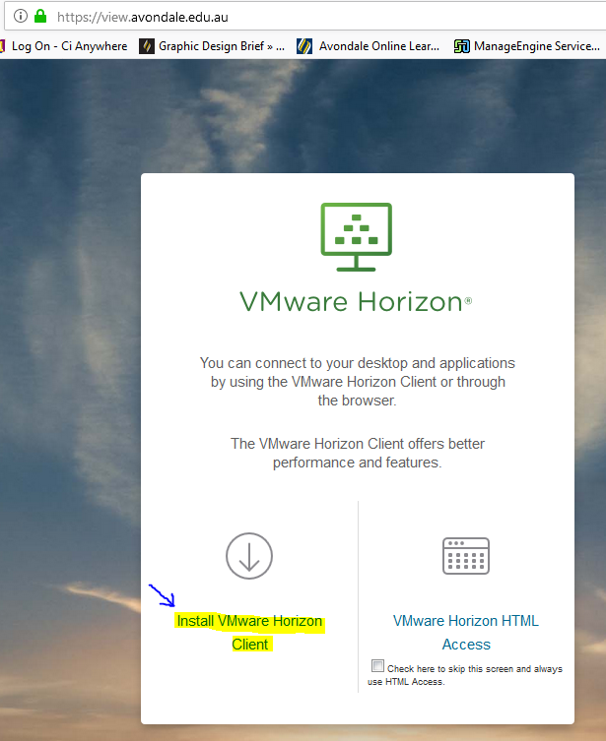
- Download the client that matches their operating system (Mac, Windows, Linux, iOS or Android) 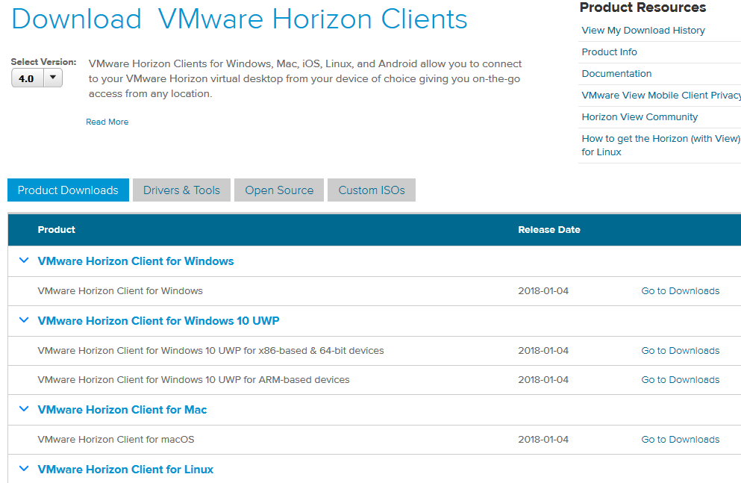

- Install the View Client
- Launch Horizon View Client – on first launch, Choose add Server, after that there should be a View profile to open.
- When prompted, the Connection Server is: view.avondale.edu.au
- Connect to the view server
- Login with Avondale username and password

VMware and ENDNOTE
The VMware working environment is a virtual workstation that sits ontop of your computers current operating software. It works remotely and so, will not communicate with your current operating software. For students this means the process of using Endnote will need to be adjusted.
Endnote will need to be downloaded into your VMware environment, you will need to register with Endnote as an online user and then sync the two version libraries so you can use them in both environments.

How To: Register with Endnote Online:
- Open Endnote and go to Tools – Sync. Or the Sync icon
- Select the sign up option in the box, and complete the sign up details. Once the account is verified the synchronisation can occur.
- You will be prompted to create a compressed back-up copy which is recommended.
- You should receive confirmation with option to sync

